Project Design Phase-II
Technology Stack (Architecture & Stack)

Date | 03 July 2026
Team ID
Project Name | Cosmetic Insights: Navigating Cosmetics Trends and Consumer Insights with Tableau
Maximum Marks | 4 Marks

Technical Architecture:
The Deliverable shall include the architectural diagram as below and the information as per the table1 & table 2
Example: Order processing during pandemics for offline mode
Reference: https://developer.ibm.com/patterns/ai-powered-backend-system-for-order-processing-during-pandemics/
Guidelines:
• Excel Dataset Collection and Processing
• Tableau Data Analysis and Visualization
• Dashboard and Story Creation
• Local Storage and Tableau Public Cloud
• No External APIs Used
• No Machine Learning Models Used
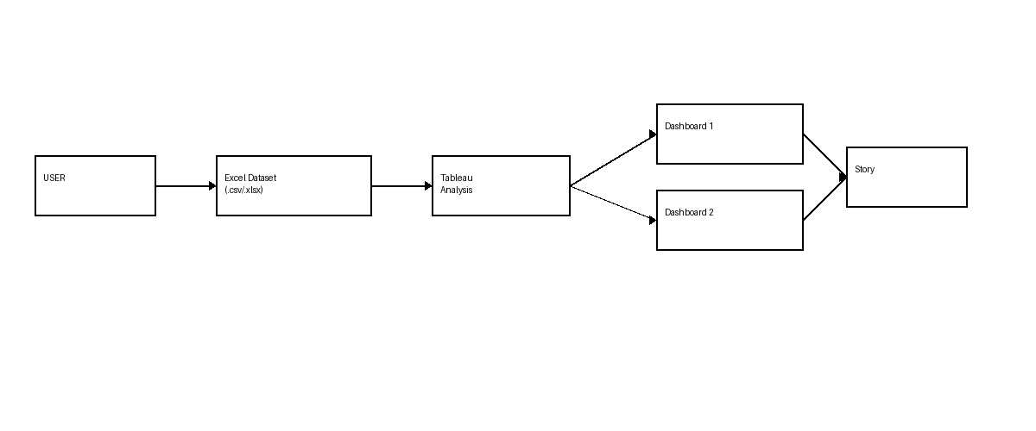
Table-1 : Components & Technologies:
S.No | Component | Description | Technology
 | User Interface | User interacts with dashboards and visualizations | Tableau Public
 | Application Logic-1 | Import and preprocess cosmetics dataset | Microsoft Excel
 | Application Logic-2 | Data analysis and visualization | Tableau Desktop/Public
 | Application Logic-3 | Dashboard and Story creation | Tableau
 | Database | Cosmetic dataset storage | Excel (.csv/.xlsx)
 | Cloud Database | Published dashboard storage | Tableau Public Cloud
 | File Storage | Store project files and datasets | Local File System
 | External API-1 | Not Used | N/A
 | External API-2 | Not Applicable | N/A
 | Machine Learning Model | Not Used | N/A
 | Infrastructure (Server / Cloud) | Dashboard publishing and hosting | Tableau Public Cloud

Table-2: Application Characteristics:
S.No | Characteristics | Description | Technology
 | Open-Source Frameworks | Visualization and analytics tools | Tableau Public
 | Security Implementations | Secure access and data protection | Tableau Security Features
 | Scalable Architecture | Supports future cosmetic datasets | Tableau Platform
 | Availability | Dashboard accessible online anytime | Tableau Public
 | Performance | Fast loading dashboards and charts | Tableau Visualization Engine

References:
https://c4model.com/
https://developer.ibm.com/patterns/online-order-processing-system-during-pandemic/
https://www.ibm.com/cloud/architecture
https://aws.amazon.com/architecture
https://medium.com/the-internal-startup/how-to-draw-useful-technical-architecture-diagrams-2d20c9fda90d

